Jeff Sherard
CSC160C11
7/16/2013

Documentation for Ch07_Ex06 Program

Problem Analysis

Write a program that uses a random number generator to generate a two digit positive integer and allows the user to perform one or more of the following operations:
a. Double the number.
b. Reverse the digits of the number.
c. Raise the number to the power of 2, 3, or 4.
d. Sum the digits of the number.
e. If the number is a two digit number, then raise the first digit to the power of the second digit.
f. If the number is a three digit number and the last digit is less than or equal to 4, then raise the first two digits to the power of the last digit.

After performing an operation if the number is less than 10, add 10 to the number. Also, after each operation determine if the number is prime.

Each successive operation should be performed on the number generated by the last operation. Your program should not contain any global variables and each of these operations must be implemented by a separate function. Also, your program should be menu driven.
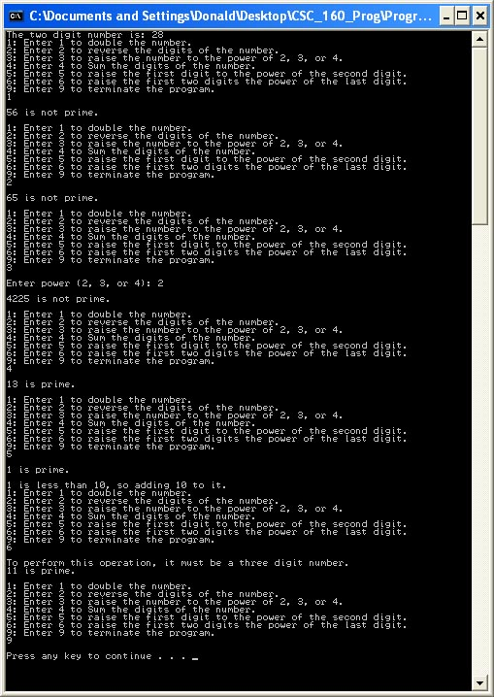

Algorithm

- Define variables:

- Get input:
Random number generator

- Calculate functions:

Double the number.
Number * Number

Reverse the digits of the number.
1234 4231

Raise the number to the power of 2, 3, or 4.
exp2 exp3 exp4

Sum the digits of the number
1+2+3+4 = 10

If the number is a two digit number, then raise the first digit to the power of the second digit
If # = xy then xpwry

If the number is a three digit number and the last digit is less than or equal to 4, then raise the first two digits to the power of the last digit
If xyz and z <= 4 then xypwrz

- Output:

User Documentation

To run the program the user will double click Ch4_Ex14.exe located on the C drive. After the program has loaded and the design is displayed, the user will be prompted to, “Press any key to continue…” which will terminate the program. Output will be displayed on the screen.

